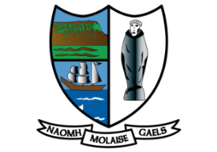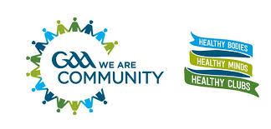

**GAA Anti-Bullying Policy Statement**

The GAA aims to create a supportive environment where any form of bullying is unacceptable. We adopt a whole organisational approach to addressing bullying and are committed to implementing structures and relevant training to deal with allegations of bullying. Incidents of bullying are regarded as serious breaches of our Code of Best Practice in Youth Sport - Our Games Our Code. We are committed to achieving an ethos of respect so as to maximise the potential of all our members when playing or participating in our Gaelic Games.

**DEFINITION**

Bullying is defined as repeated aggression, be it verbal, psychological or physical, conducted by an individual or group against others.

**THE GAA SEEKS TO ENSURE THAT:**

● Incidents of bullying behaviour are addressed appropriately

● All persons in membership of the Association or attending our games or activities are aware that bullying behaviour is unacceptable in the GAA.

**DEALING WITH BULLYING**

The Code of Behaviour when working with underage players provides good practice guidance in relation to the prevention of bullying.

If you are aware of or have a concern that bullying behaviour is happening within your Club you should report the matter to your Club Children’s Officer.

We recognise that incidents of bullying are a breach of the Code of Behaviour and of our Give

Respect - Get Respect initiative and all such incidents will be dealt with accordingly.

Signed: Date: 01/01/2021

Club’s Children Officer: Catherine Keaney

Club Name: St Molaise Gaels GAA Club