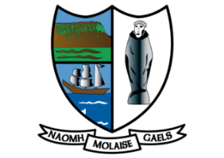 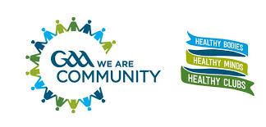

**GAA Mental Health Charter**

Our commitment to promoting and maintaining positive mental health for all our members

**RESPECT**

Everyone in the club will respect the rights, dignity and worth of each person, regardless of ability, age, culture or ethnic origin, gender, sexual orientation, or religious belief.

**ENCOURAGING**

The club will ensure that everyone is treated equally, fairly, and encouraged to do their best.

**SUPPORTIVE**

The club will ensure that all members are aware of and encouraged to use the support system that the club and its varied members provide.

**POSITIVE**

Everyone’s positive contribution to club life is recognised and we understand that every member has

an important role to play.

**ENABLING**

We will create an environment and atmosphere within all club activity that enables all members of the Association to maintain as well as develop their mental health and emotional wellbeing.

**CONSIDERATE**

Everyone within our club will be listened to and be given an opportunity to contribute to express their opinions without reprisal or judgement.

**TOLERANT**

An element of discipline will underpin our club to ensure that our games are controlled and that values such as honesty, equality, and fair play are promoted at all times: St Molaise Gaels GAA Club **is committed to following the GAA’S Mental Health Charter**

Signed: Date: 02/01/2121

Sean Herron

Chairperson St Molaise Gaels GAA Club