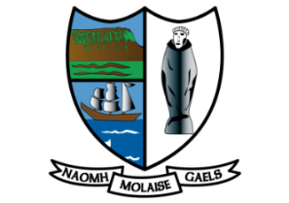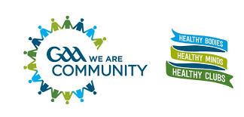

**GAA’s Physical Activity Guidelines**

St Molaise Gaels GAA Club aims to create a supportive environment in which it already promotes physical activity for all its members and the wider community, to make the Association a healthier place for everyone to enjoy. The club is committed in supporting a whole club approach to embed and implement the following physical activity guidelines.

In line with Healthy Ireland’s National Physical Activity Plan the below guidelines aim to:

**Educate** members and the wider community on the recommended levels of health enhancing physical activity guidelines

**Acknowledge** the work GAA communities are already doing in promoting physical activity and alternative ways the club can support physical activity for its members and the wider community

**HOW MUCH PHYSICAL ACTIVITY SHOULD WE BE DOING?**

**Children and juveniles (aged 2-18)**

Children and juveniles should be active, at a moderate to vigorous level, for at least 60 minute every day. Include muscle/bone strengthening and flexibility exercises 3 times a week.

**Adults (aged 18-64)**

Adults should be active for at least 30 minutes a day of moderate activity on 5 days a week (or

150 minutes a week).

**Older adults (aged 65+)**

Older people should be active for at least 30 minutes a day of moderate intensity activity on five days a week or 150 minutes a week with a focus on aerobic activity, muscle strengthening and balance.

**Adults with disabilities**

People with disabilities should be as active as their ability allows them to be. Aim to meet adult guidelines of at least 30 minutes of moderate-intensity activity on 5 days a week.

The key message is that physical activity is for everyone, and any level of activity is better for your health than none.

**List of physical activity actions the club supports (Please insert actions that suit the clubs need or what the club already supports in this space)**

* The club provides a safe environment for all to allow its members and the wider community reach their daily physical activity guidelines.
* The club promote physical activity opportunities each week to its member and wider community.
* The club promotes a ‘Sli Ní Slainte’ route around its grounds for all to use.
* Bike rack
* The club welcomes other physical activity community groups t